Azure Assignment

1. Creating a virtual machine with 2 subnets. Each subnet have 16 Ips only.

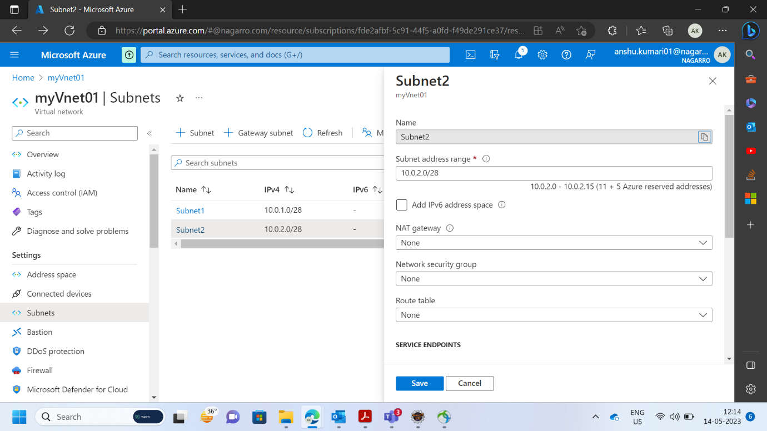

1. Inside one of the subnets, create a VM and deploy an application code inside it and it should leverage the database on the cloud (any existing application created by you before)

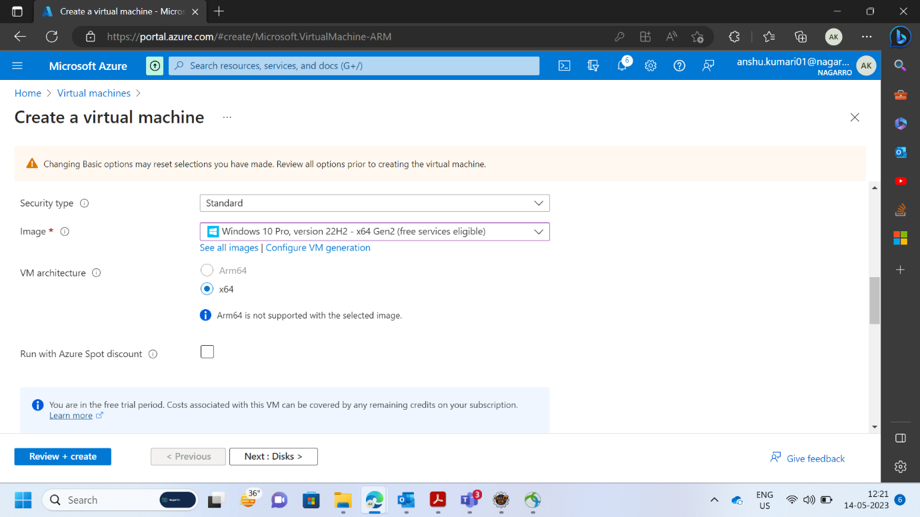

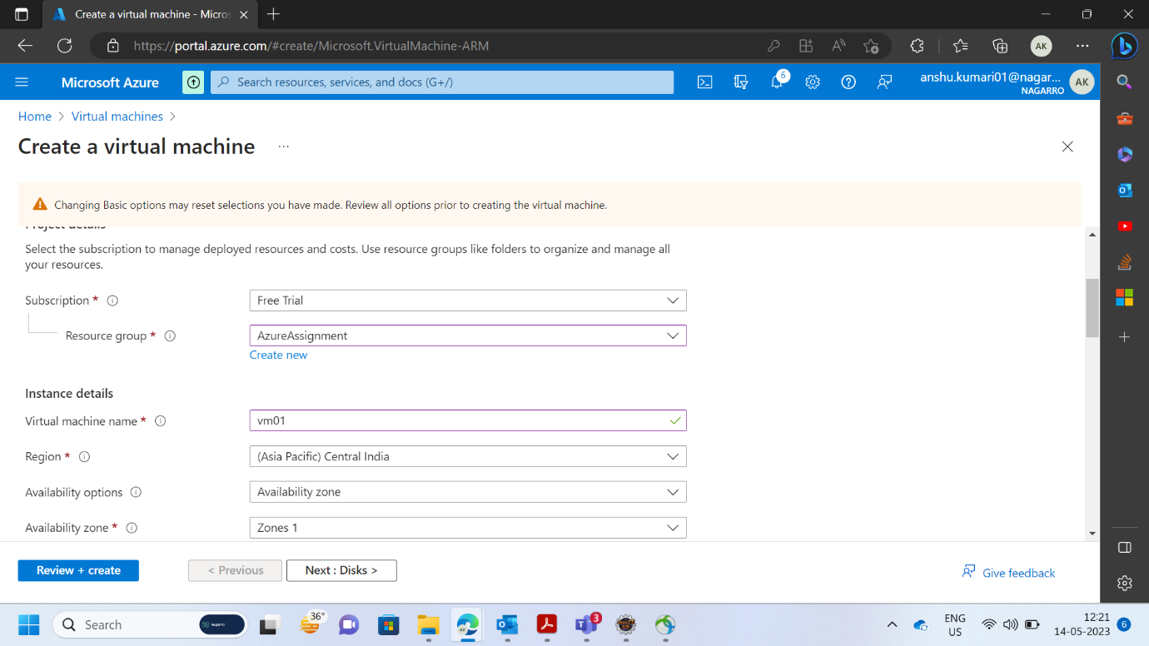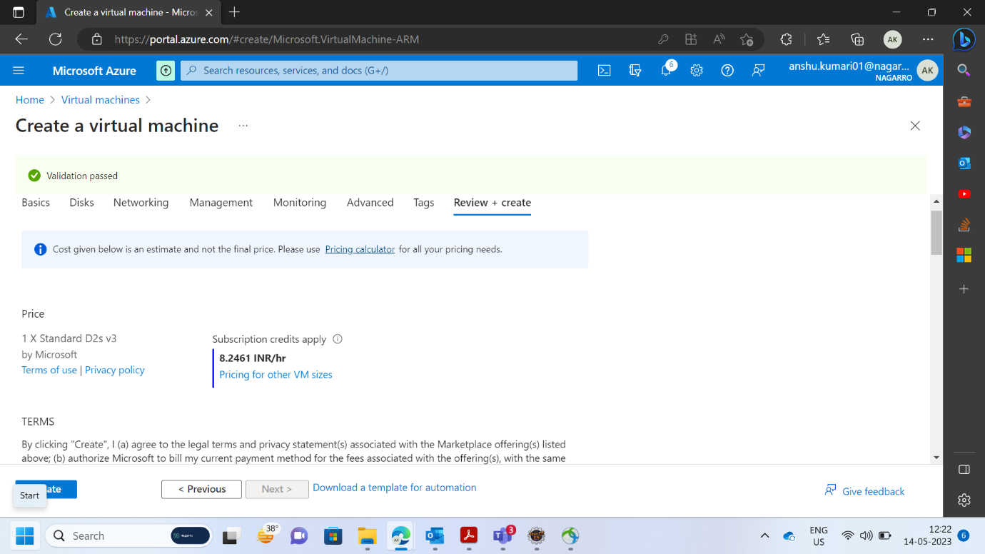

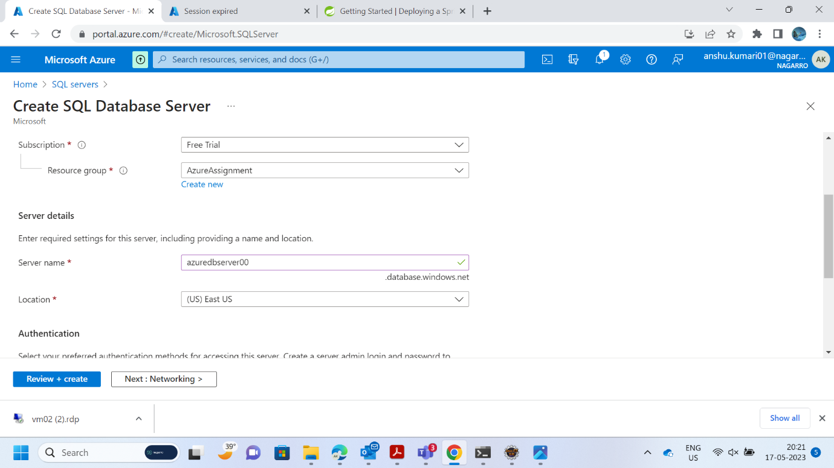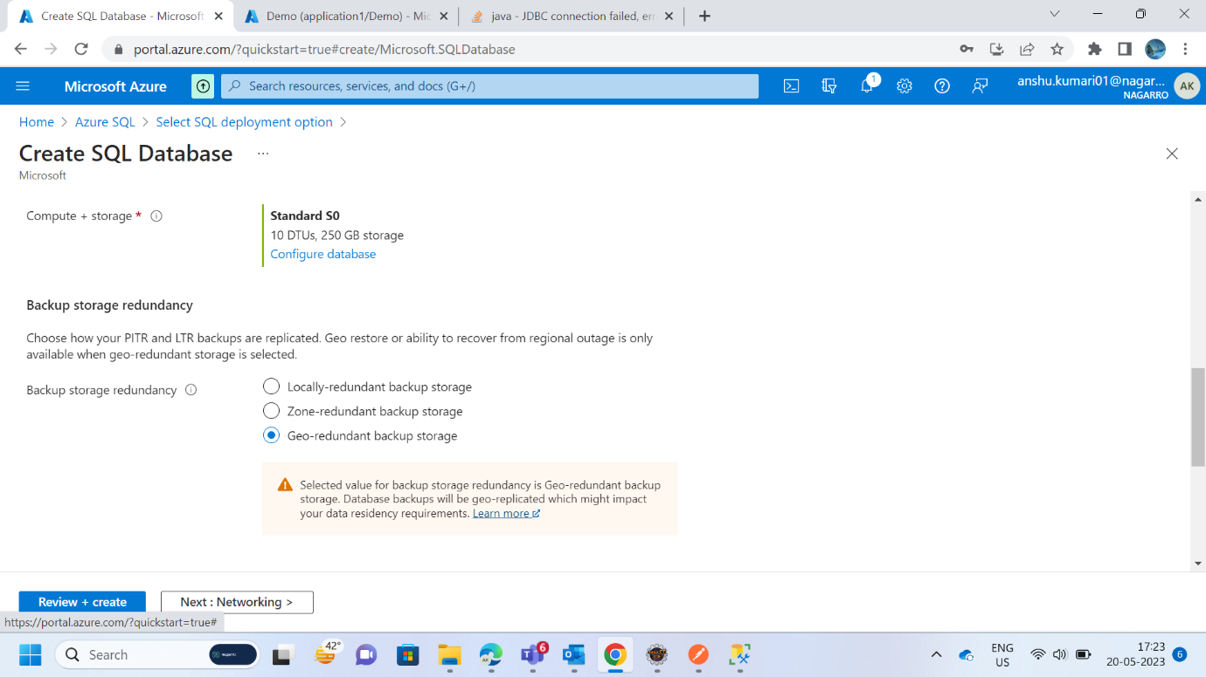

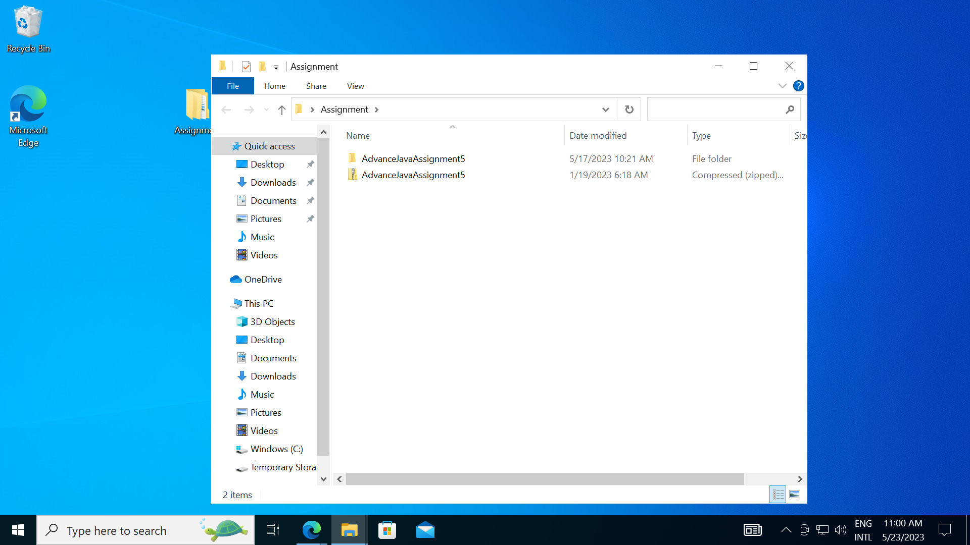

1. Deploy the same application to Azure App Service. It should also leverage the database on the cloud.

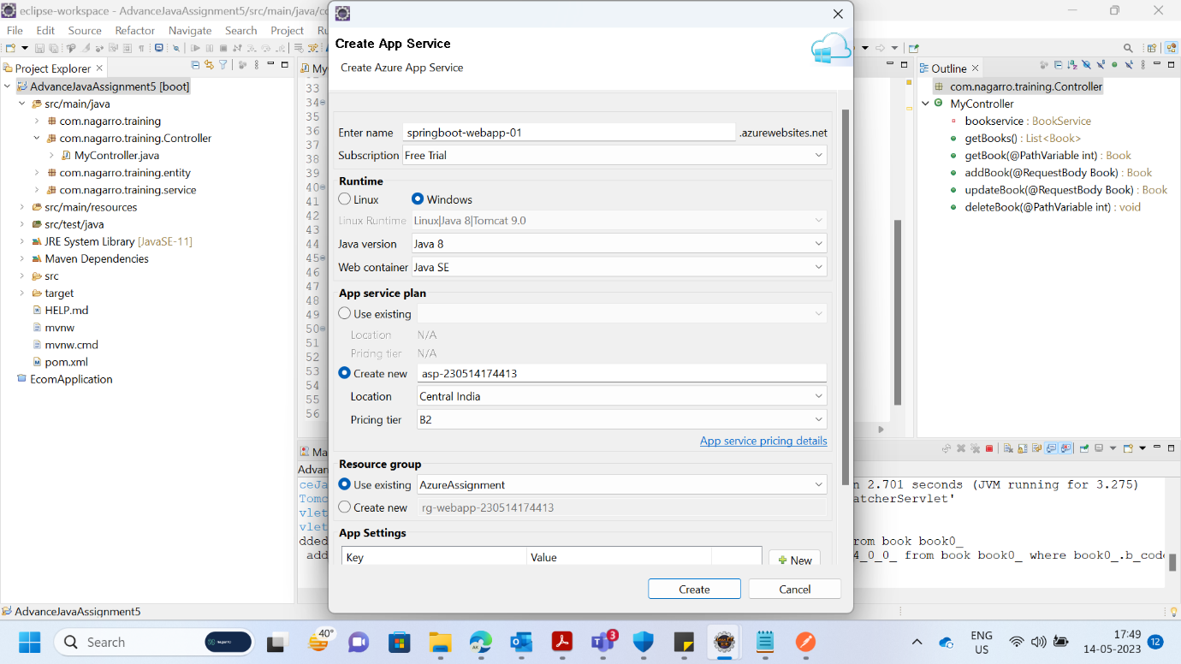

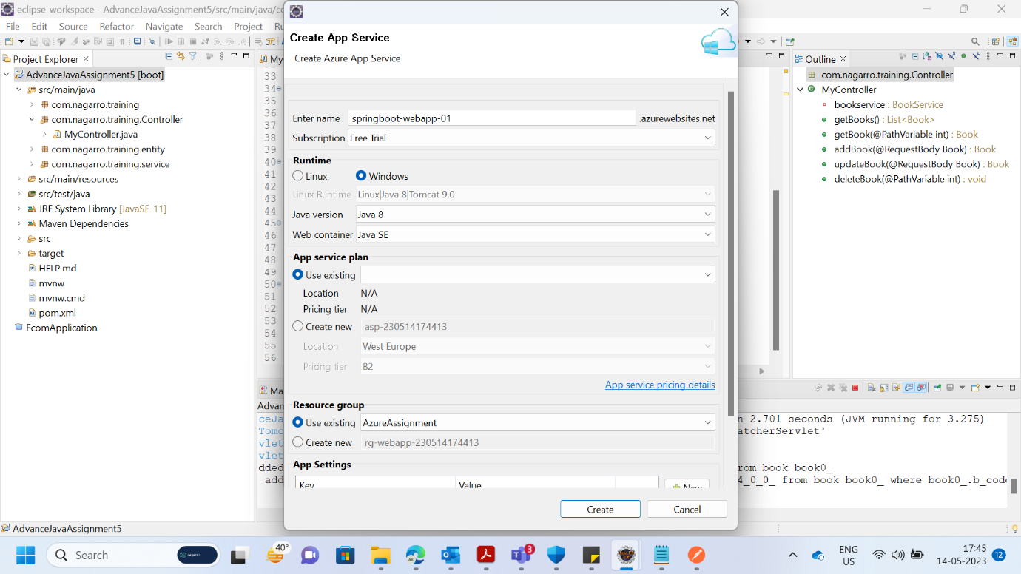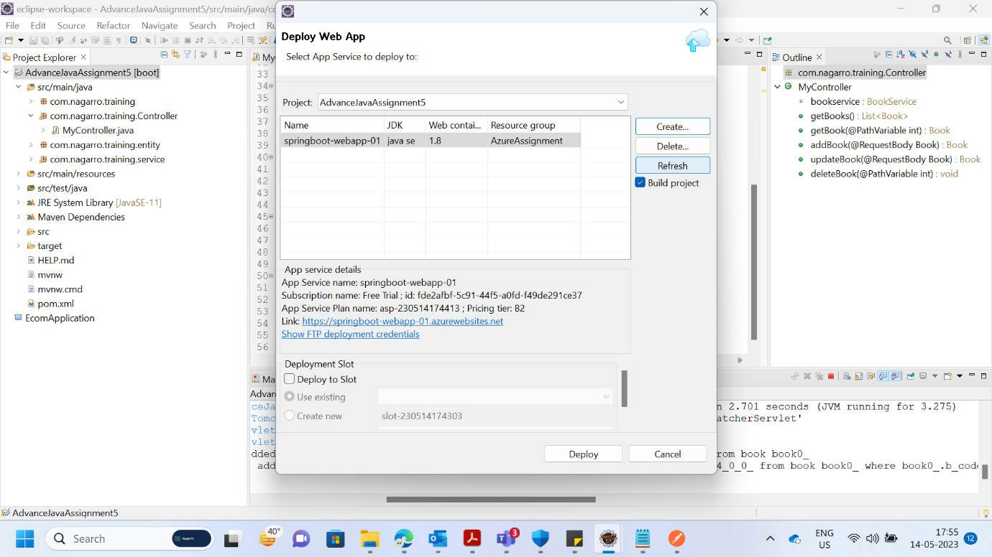

1. Create the AKS cluster (2 nodes, smallest size VM) and deploy any two services on it. Services should be accessible from the internet.

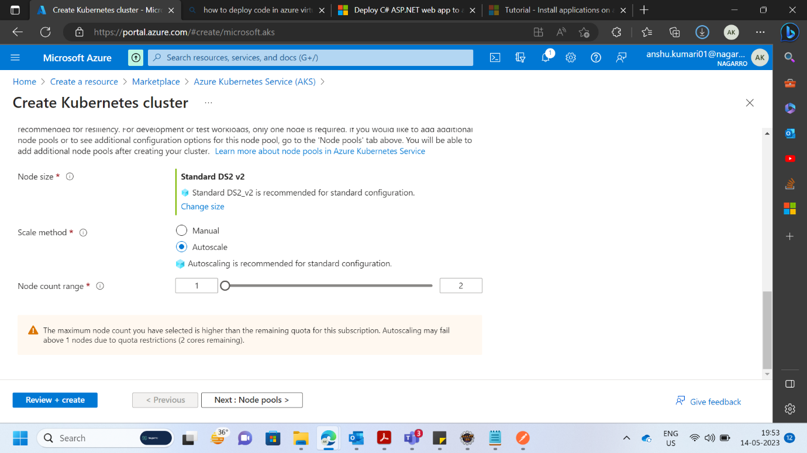

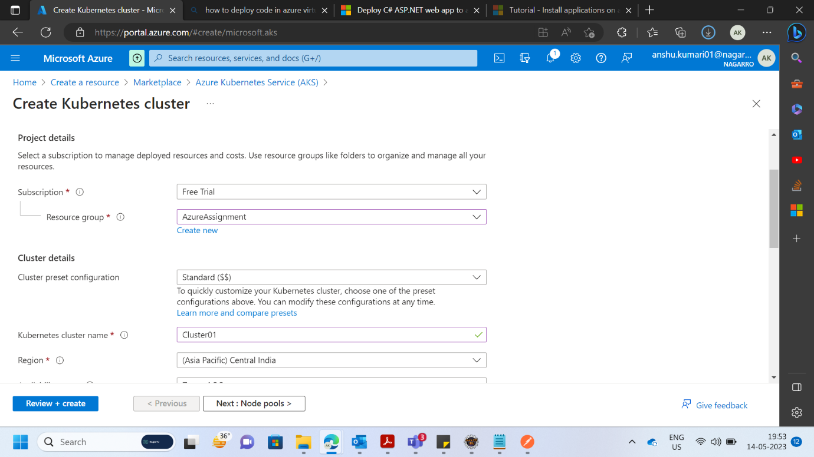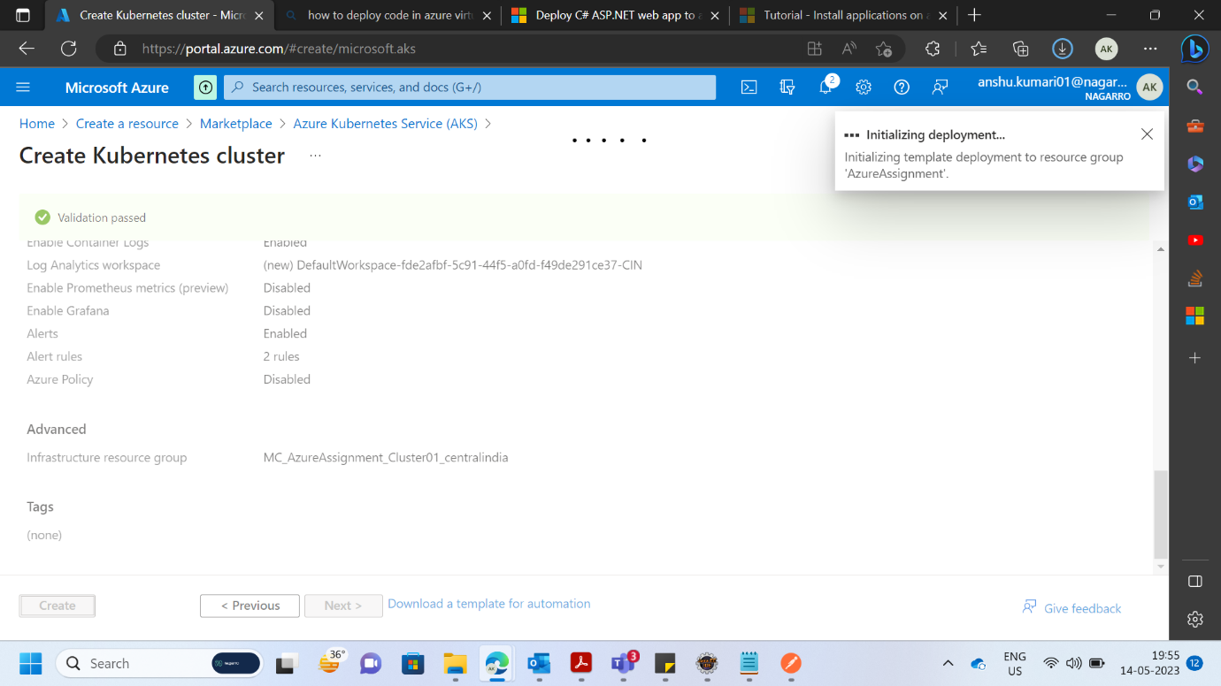

1. Create an Azure function that should trigger as soon as you upload a file in the blob storage. Function should be able to print the name of the file uploaded in the function.

